EXCEL BUDGETING FOR FEDERAL CAPITAL PROSECUTION CASES

NOTES ABOUT MICROSOFT EXCEL

Microsoft Excel was selected as the program to drive this budgeting software because it is widely available and is Windows-based. The files created in Excel are managed in the same way on your computer as Word Perfect and Microsoft Word files. The files are easy to manage and easy to attach to emails.

This program was developed in Excel 2000. As there have been significant changes to the latest version of Excel (2007), there are some special considerations that are discussed for that version.

A basic knowledge of Excel is all that is necessary to use these budget spreadsheets. Excel is menu driven and has helpful icons like other popular windows-based programs. Most areas of the spreadsheets are password protected and therefore normal Excel functions, such as adding rows and columns, adding and editing formulas, and adding text areas are not allowed.

Excel spreadsheets are also referred to as “workbooks.” This is because it allows the use of multiple worksheets or pages that interact with each other. As described in this guide, this budgeting spreadsheet file utilizes many separate worksheets to make the budgeting process more clear and user-friendly. You can move from sheet to sheet by selecting the desired worksheet from the tabs across the bottom of the spreadsheet.

You can move around a sheet by tabbing from cell to cell, using the arrow buttons on your keyboard or clicking on the desired cell. It you try to access a protected part of the spreadsheet, you will get a warning that the cell is protected (click OK to proceed).

Because so much of the data entry will be numerical, it is suggested that you use the number lock on your keyboard so that your number pad will function like a calculator. This will probably make data entry more efficient and accurate.

Budgeting Overview and Set Up

This spreadsheet has been developed to help manage and monitor federal capital prosecution case budgets. It utilizes standard categories, rates, and terminology in use by the 6th Circuit and the districts therein. Through consistent use of this program, the Circuit will be able to better estimate cost and time requirements necessary to complete the various stages of a capital prosecution case.

The budgeting file, which will be emailed to the lead attorney, is Microsoft Excel-based and requires minimal understanding of the Excel program itself. In versions of Excel prior to 2007, when you attempt to open the file, you should (if your security level is set correctly) get a message similar to the following:

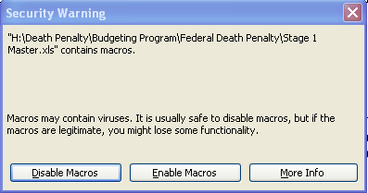

Viruses are sometimes transferred through macros, so your system may warn you that this program contains macros. This budgeting program is controlled by the court and is considered to be safe from viruses. In order for the program to function properly, you must select “Enable Macros” if you get this, or a similar message. If you don’t get this message, you need to cancel opening the file and re-set your security level as described below.

To set your security level properly, open a blank Excel file and go to Tools on the Menu Bar, click Options, click on the tab Security, click on Macro Security and set the Security level to Medium, as indicated:

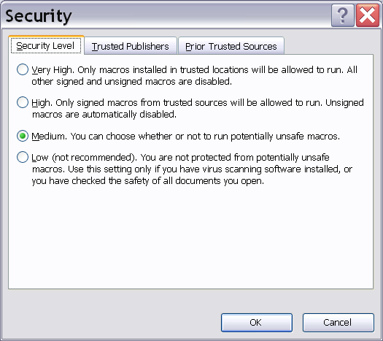

If you have Excel 2007, the file will open, but you may get a security warning at the top of the file (below the menu bars):

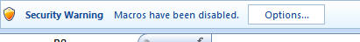

Click on the Options button and choose “Enable this content” as shown:

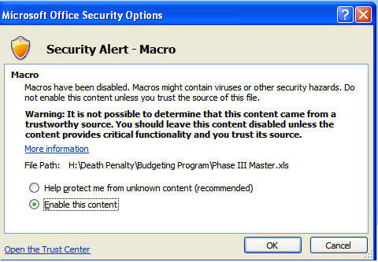

Header Sheet

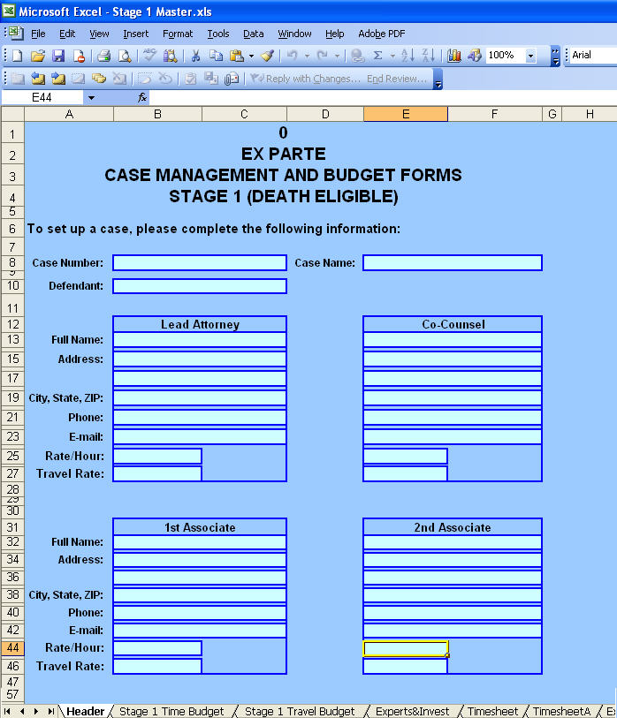

Capital prosecution cases are divided into three stages, each individually budgeted. Each stage of the program consists of several sheets that detail different aspects of the costs incurred in that stage and a comparison to budgeted amounts. The program opens on the Header page (shown above). Note: if there are no associates assigned to the case, the section for associates will be hidden. The various sheets are listed on tabs (indicated by the green arrow) along the bottom edge of the Excel file.

On each sheet, when attorney data is required to be entered into the spreadsheet, the field will be shaded in light blue. Fields that are shaded in a rust color and unshaded “Authorized” columns are for the court to fill in. Generally, all other fields will be locked, to prevent inadvertent entries into restricted areas of the program, where formulas and links cannot be changed. You will get an error message if you try to enter data into a locked field.

There are eight sheets (indicated by the tabs) in the program, most requiring court and/or attorney input (use the navigation arrows in the lower left corner of the screen -- indicated by the red arrow -- to scroll through the sheets). If the court has approved associate attorneys in addition to co-counsel, the appropriate sheets will automatically expand to accommodate the additional information. In addition, a separate timesheet and a separate voucher sheet will appear. The sheets in the spreadsheet are as follows.

- Header - This sheet gathers summary information and populates the part of the voucher that requests attorney information.
- Stage X Time Budget - This sheet asks for the proposed number of hours for each attorney in each of the categories provided. The court fills in the “Authorized” columns.
- Stage X Travel Budget - This sheet asks for the proposed number of hours required and the associated travel expenses for attorneys. Again, the court fills in the “Authorized” columns.
- Experts & Invest - This sheet asks for an estimated rate per hour, estimated hours, and summary information for the experts expected to be used in this Phase. The court fills in the “Authorized” columns. Expert Type is selected from a drop-down list.
- Timesheet/TimesheetA - This sheet gathers detailed hours spent by the lead attorney or co-counsel (or associates) by date and by category. It provides a rollforward budget balance at the top of the spreadsheet. It also allows the court to make adjustments at the bottom of the spreadsheet.
- Expense Sheet - This sheet gathers detailed expense information – both travel and general expenses. It also allows the court to make adjustments at the bottom of the spreadsheet and provides rollforward budget balances at the top of the sheet.
- Voucher/VoucherA - The voucher (CJA Form 30) is automatically filled in, except for the light turquoise fields. These are filled in by the attorney and are often facilitated by drop-down boxes that make the form easier to complete.
- Admin - This sheet is primarily for the court and circuit administrators. It summarizes each area of the budget, comparing proposed, authorized, and actual expenses. It offers a detailed snapshot of how the budget stands. Attorneys do not fill in any information on this sheet.

Getting Started

The court initiates the budgeting process by entering some basic case information (and usually attorney information) into the file. The spreadsheet will then be emailed to the lead attorney who will complete/correct the information on the header page as well as fill out the three budgeting worksheets: Time Budget, Travel Budget, and Expert/ Investigator Budget (explained in greater detail infra). Once completed, the file should be emailed back to the person who originally emailed it to you (typically the Court’s CJA Circuit Case Budgeting Attorney (“Budgeting Attorney”). In addition, a copy of those three budget sheets should be printed and filed with the court, accompanied by a detailed motion or declaration explaining the necessity of the work or service.

The court will review the budget and the presiding Judge will make adjustments to the proposed budget where necessary. The adjusted budget will be entered in the “Authorized” columns by the court or Budgeting Attorney. The Excel file will then be emailed back to the attorney. This file will serve as the authorized budget as well as the mechanism for you to report your time and expenses to the court on a periodic basis.

Each time you submit time and expenses, you will email the file to the CJA Budgeting Attorney who will import the information into a master file and return an updated file to you for your next submission. Each time the court imports your data, all of the cumulative budget information will be updated.
Budgeting Process

Stage 1 (2 or 3) Time Budget

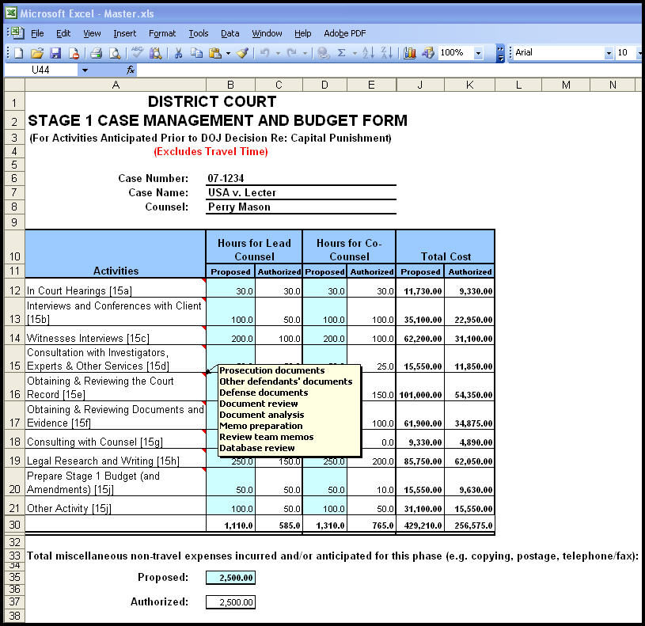

The lead attorney must complete the Time Budget, for hours and for administrative expenses. Fill in information for fields shaded in light turquoise only, all other fields should be locked and will give you an error message if you attempt to enter or change data.

Enter your estimate of the number of hours that the case will require in each of the categories listed, both for you, co-counsel, and, if appropriate, associate attorneys (if associate attorneys have been authorized, there will be additional columns on this sheet). Again, exact hours may not be known, but plan the management of the case so you can provide your best estimates for budgeting purposes.

To facilitate the categorization of hours, if the cursor is placed within a category cell (with the red triangle in the upper right corner) a list of tasks appropriate to that specific category will appear, as shown on the following example.

The program will automatically calculate the costs based on the attorney rates as entered by the court on the Header sheet. The following example shows both proposed hours for lead and co-counsel and authorized hours as entered by the court after the budget is approved.

At the bottom of the Time Budget sheet, fill in the estimated administrative expenses that you anticipate for this Stage (in the light turquoise box). These expenses include fax and telephone charges, copy, postage, and express mail/messenger expenses.
Stage 1 (or 2 or 3) Travel Budget

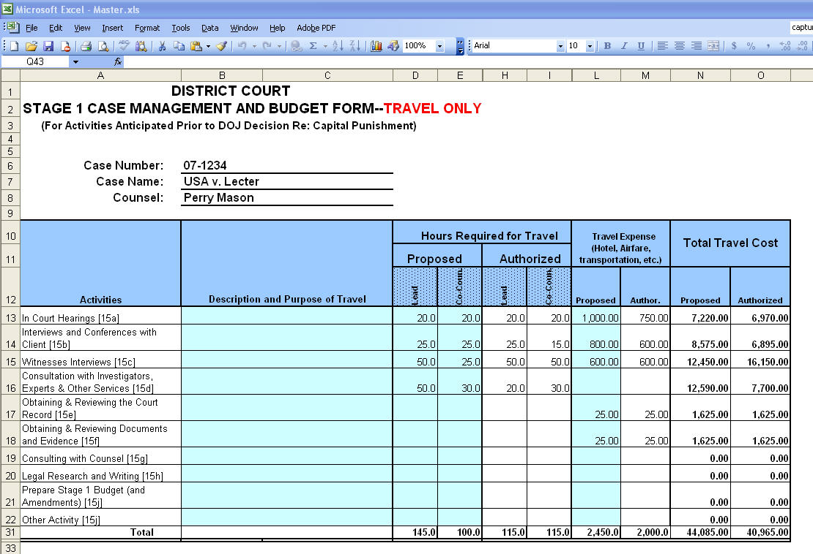

The lead attorney on each capital case must complete the Travel Budget for travel time and expenses. Again, you need only fill in information for fields shaded in light turquoise. All other fields should be locked and will give you an error message if data is entered.

Enter the travel hours anticipated, by category, that the attorneys will use along with anticipated travel expenses. Each line of the travel budget should have a brief description of the purpose and nature of the travel, along with the number of trips anticipated. Detailed information showing the necessity of the travel should be included in the accompanying motion or declaration. The table will reference the rate/hour set by the court. As with the Time Budget, the table will expand to accommodate associate attorneys should such be authorized by the court.

Expert/Investigator Budget Sheet

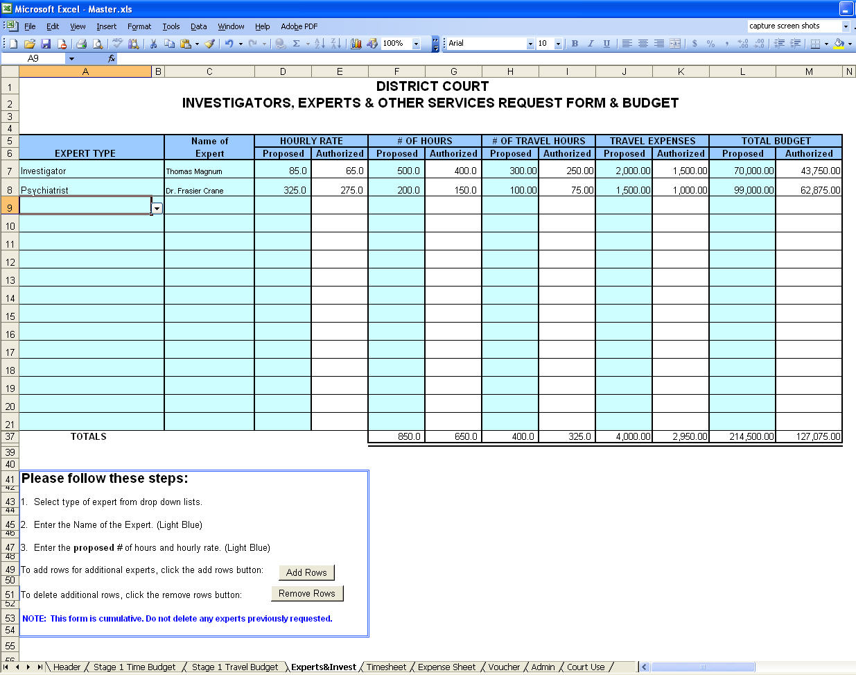

To complete the Expert/Investigator Budget, click on the “Experts&Invest" tab. This sheet works similarly to the first two. The “Expert Type” column has a drop-down menu (as indicated by the red arrow) to assist in the selection of the appropriate expert. The name of the expert should be entered, along with the anticipated rate/hour and the anticipated hours and expenses needed for this phase of the case.

The default setting for this sheet accommodates 15 entries. However, if more than 15 experts are engaged, the sheet can be expanded an additional 15 rows by clicking on the “Add Rows” button.

Once these three budget sheets have been completed, email the file to the CJA Budgeting Attorney. The proposed hours and expenses will be reviewed by the Judge and any adjustments deemed appropriate will be made. The adjusted budget will be entered into the authorized columns and will be the authorized budget from that point forward.

The file will be emailed to you with all of the budget information populated. The file now becomes a tool to record actual hours and expenses and a simple means of reporting them to the court. A managerial by-product of the file will be a comparison of actual amounts expended to the authorized budgets on an ongoing basis. There is also an automated CJA 30 voucher that requires very little input, since it populates as hours and expenses are recorded on the time and expense sheets.

Getting Paid

Timesheet

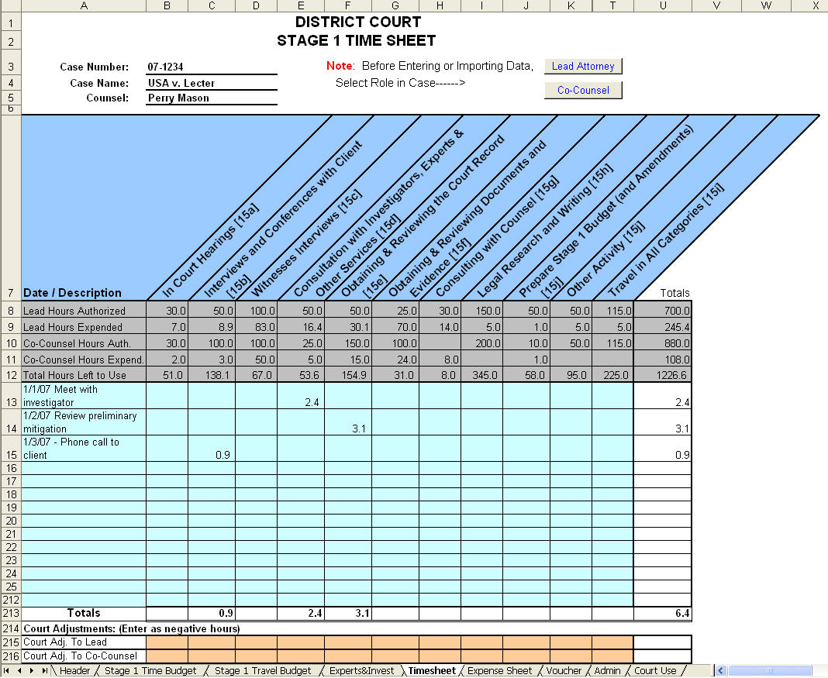

The timesheet page records attorney time spent in the various categories associated with this particular stage of the case. In the date/description column, list the date and as detailed a description as required by the court. Time should be input in tenths of an hour increments in the appropriate corresponding category. Attorneys should not share their timesheet with each other; every participant must use their own timesheet to record and submit their time. If there are associate attorneys assigned to the case, a different timesheet (labeled TimesheetA) will be available. To avoid confusion, TimesheetA will be hidden if there are no associates working on the case.

It is very important that you indicate at the top of the timesheet if you are the lead attorney or co-counsel (or, if you are an associate attorney, whether you have been designated on the header sheet as Associate #1 or Associate #2), by clicking on the appropriate button. When you click on the appropriate button, the cursor will automatically appear on the line for counsel’s name. You will need to type in your name on each submission.

The program will keep a running total of how many hours you have used and how many are left in the budget. The program will total the hours in all columns and rows automatically.

To avoid entering your time both on your office billing system and on this budget sheet, it is recommended that you keep the billing records on the budgeting program. When a payment request is filed with the court, an entry of the defendant’s name and gross billed amount can be entered into your office billing system. When payment is received, the credit can be recorded in the billing system. This enables you to keep all billing and credits on your office billing system without entering your detailed time descriptions into two systems.

If you run out of rows to enter your time, there are two buttons at the bottom of the sheet that will allow you to display either an additional 25 or an additional 175 rows. There is also a “Hide Add’l Rows” button which hides only the rows that have been added if one of the two display rows buttons have been clicked. If you enter time on these additional rows and then click the hide rows button, the rows will not be seen, but any data entered will still be there. You may want to use the “Freeze Panes” option to “freeze” the categories so that you can see them at all times. To do this, put your cursor on row 13, select Windows from the Tool Bar and select “Freeze Panes” – this will hold everything above line 13 stationary, but you will still be able to scroll down the rest of the page.

Once all time has been entered, follow the instructions at the bottom of the sheet. Remember, this data will be emailed to the court, so do not delete any information before the file is sent.

You may want to print a copy of every completed timesheet for your records. Once the time sheet is complete, you can verify the accuracy of the hours on the voucher sheet, and then proceed to the expense sheet.

Expense Sheet

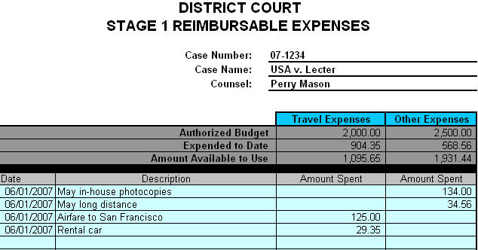

The expense sheet is where attorneys record their travel and administrative expenses. The miscellaneous case data at the top, along with the authorized budget will automatically carry forward from other parts of the spreadsheet. On the light turquoise lines, enter the date, description and amount of each expense (there are 40 rows in which to enter expenses). As expenses are listed, they will be added to the “Expended to Date” total at the top of the sheet, and will reduce the “Amount Available to Use.” Similar to the timesheet, the Court has an area at the bottom of the sheet to make any adjustments considered necessary. These adjustments will also calculate into the rollforward totals at the top of the sheet.

You may want to print a copy of the completed expense sheet for your records. Once you have finished, verify the accuracy of the amounts on the voucher sheet.

Voucher/Voucher A

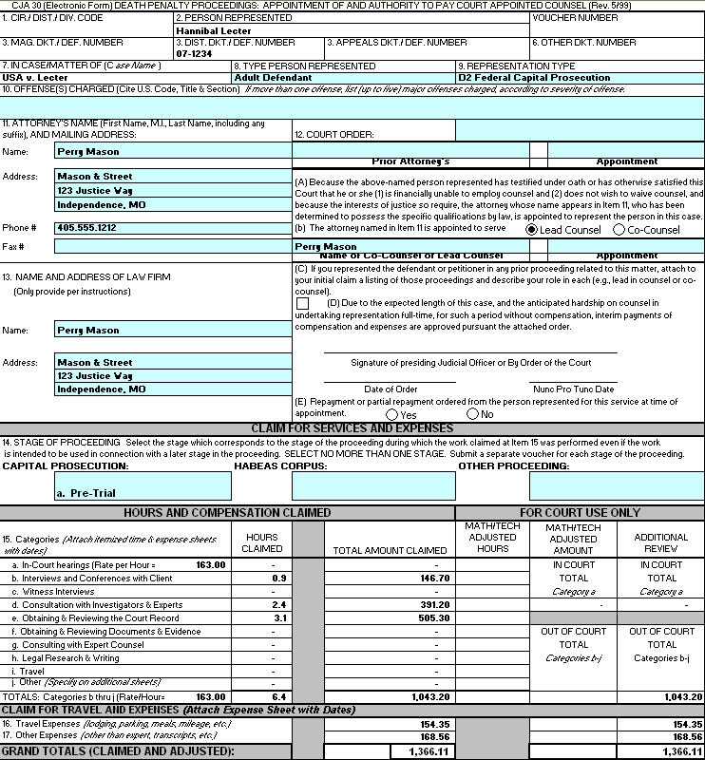

The automated CJA 30 voucher contained in the program is designed to minimize attorney input. Many of the fields contain drop-down boxes to aid in the selection for that field. As in other areas of the spreadsheet, the fields that require your input will be shaded in light turquoise.

All of the actual time and expense data entered on the time and expense sheets carry forward to the voucher. In addition, much of the general case and attorney information entered on the header screen is carried forward to the voucher. If you need to make adjustments to time and/or expenses before submitting the voucher to the court, you must make changes on the Timesheet and/or Expense Sheet, not on the voucher itself.

Once you have completed the voucher information and reviewed it for accuracy, print the voucher for the court and for your records. Most courts will require that you sign the voucher and submit the signed voucher to the court, along with hard copies of the detailed description of your time and any expense receipts.

Important Note: The “Clear Forms” button at the bottom of the voucher sheet, in the Instructions box, is for court use only. Selecting this button will clear all of the data that you have entered on the time and expense sheets.
Admin. (Budget Summary)

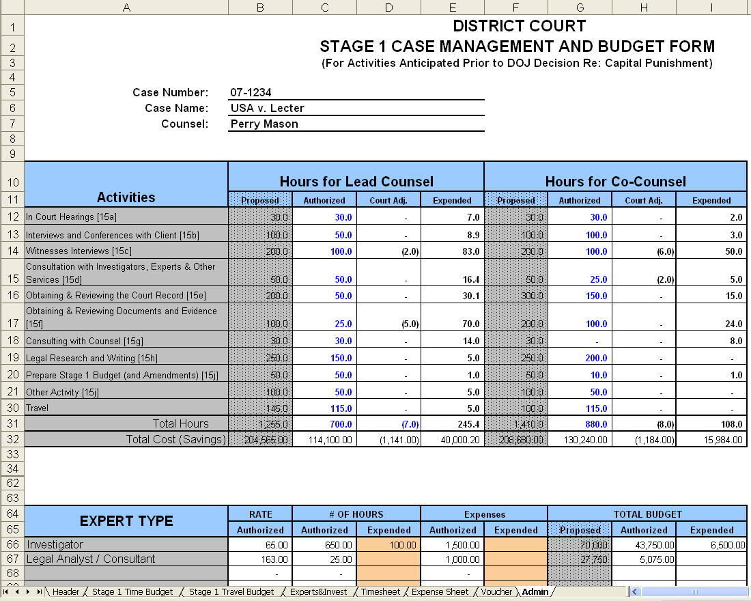

The budget summaries are on the sheet tab labeled “Admin.” From the attorneys’ standpoint, this sheet is informational only. It summarizes the various parts of the budget for this stage of the case and makes comparisons between the proposed, authorized, and expended hours and amounts, as well as listing any adjustments made by the Judge. These tables will alert you when certain areas of the budget are close to being fully expended, so that you can make a timely request to amend the budget. The court will also use this information to monitor the progress of the case, as well as to gather statistical data to compare to other cases.

Time and reimbursable expenses for authorized experts, investigators, and/or paralegals that are submitted to the court will be manually updated by the Budgeting Attorney using the rust-shaded areas on the Admin Sheet.

The Admin Sheet also highlights the adjustments made by the court during the course of the particular phase you are in and keeps track of the total case budget.
Budgeting Process

- You will receive an emailed file from the court’s CJA Budgeting Attorney (or designee) with the name “[Defendant] Stage X Budget.xls” (e.g., Jones Stage 1 Budget.xls) or something similar. This file will contain rate information set by the court, as well as the case name and number and basic attorney information. Please ensure that all information on the Header Sheet is accurate. Using this file, you will complete the time, travel, and expert/ investigator budgets.
- Once these sheets are complete, save the file for your records and email it back to the person who emailed it to you (keeping the same name).
- After the budget is authorized by the court, the court’s CJA Budgeting Attorney will email you a file called “[your name] Interim 01.xls “(e.g., Mason Interim 01.xls). You may wish to copy this file as a separate version of the authorized budget (renaming it Jones Stage 1 authorized budget).
- Using this file labeled interim 01 (or whatever number), fill out the Timesheet and Voucher, save it with the same name for your records and email it back to the CJA Budgeting Attorney(in addition to filing with the court a hard copy of the voucher with your signature and any necessary receipts).
- The CJA Budgeting Attorney will send back Mason Interim 02.xls, which will have the info from the first interim file, but the timesheet and voucher will be blank for your next submission. Using this file, again fill out the Timesheet and Voucher for your next payment request, save it for your records, and email it back to the court.
- The process is repeated until the end of the stage.

If co-counsel and/or associate(s) are authorized by the court, they will receive separate interim vouchers with their names. All counsel authorized in a case must fill out their own timesheet and voucher. The CJA Budgeting Attorney will import each attorneys file into a Master file that will contain a cumulative accounting of the time and expenses of all attorneys. This Master file will then be used to send each attorney their new interims, so that each attorney will be aware of the status of the budget.

File Management

It is suggested that you keep separate files for each phase of a case (and for each defendant, if you represent more than one). Your files may look something like this:

C:\DEATH PENALTY CASES

Lechter CR 01-00012 (folder for each defendant)

Stage 1 (folder for each stage)

Lecter Stage 1Budget.xls (your original budget submission to the court)
Master.xls (the authorized budget)
Mason Interim 01.xls (first timesheet/voucher)
Mason Interim 02.xls
Mason Interim 03.xls

You will have many “Interim” files in each stage – one for every voucher you submit.

It’s your decision whether or not you’ll keep each interim file. You should do so only if you want an electronic record of each interim submission (keep in mind that the most current interim file is cumulative). The more interim files you keep, the more space it takes on your computer, and since there could be many interim files (particularly in the later phases), you may want to consider transferring the previous interim files onto a disk or USB device.

Please note that all three sheets you will have completed at this point (and the other five sheets) are contained in one file. There is no need to email each sheet separately.
Once the court receives the file, it will have the responsibility to review the data and the Judge may disallow certain hours spent. They will do this at the bottom of the sheet (court use areas are shaded in rust).

